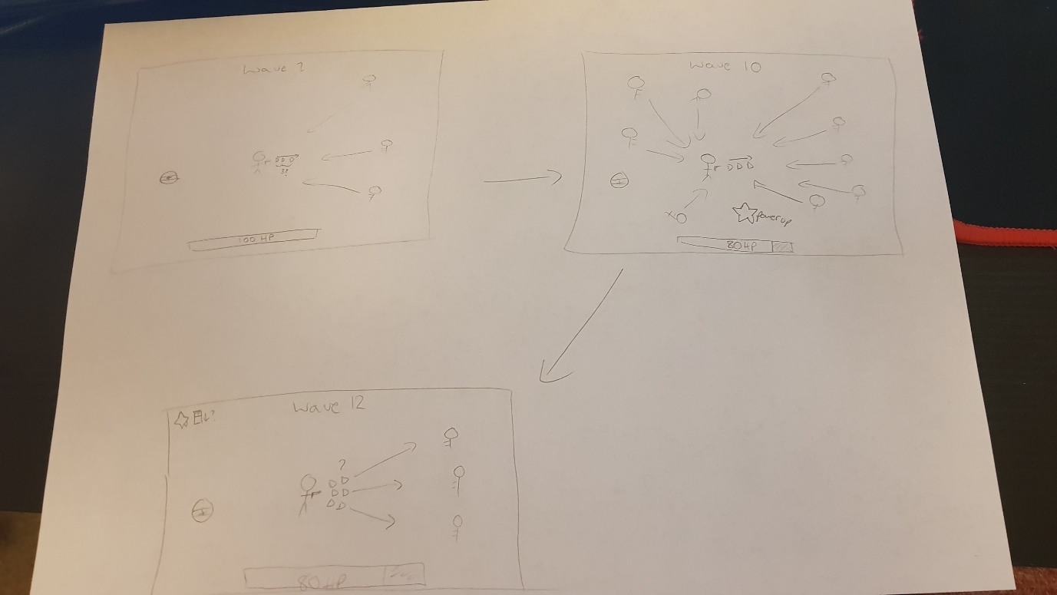Appendix 3: Background

Initial Storyboard

My game concept behind Delta-Zone is to create something similar to the 1982 arcade game, Robotron: 2084. The idea was to make a multidirectional shooter and tackle waves of enemies in order to reach the highest score. One thing I originally planned to implement (as seen in my initial storyboard below) similar to Robotron: 2084 was to create power ups, however in the end I never got round to this, however I think it would be a great addition to the game, for instance bringing in different firing patterns, or maybe invincibility or one-shot bullets, there are a few routes to go down.